1. Update your system:

sudo apt update && sudo apt upgrade

```

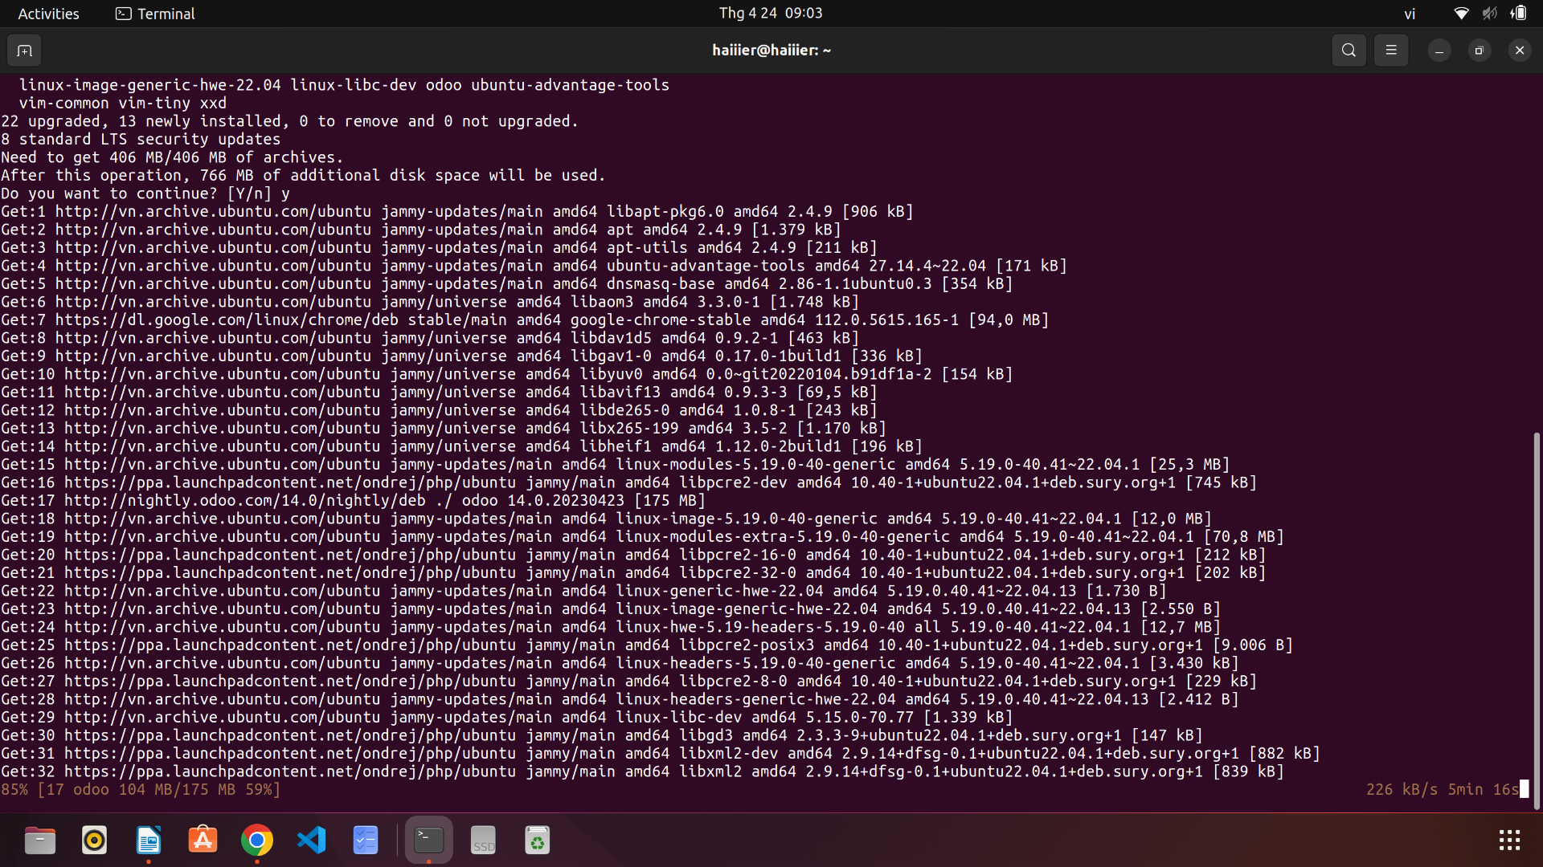

2. Install Apache2, MySQL, and PHP:

sudo apt install apache2 mysql-server php libapache2-mod-php php-mysql php-curl php-gd php-mbstring php-xml php-xmlrpc php-intl php-zip

```

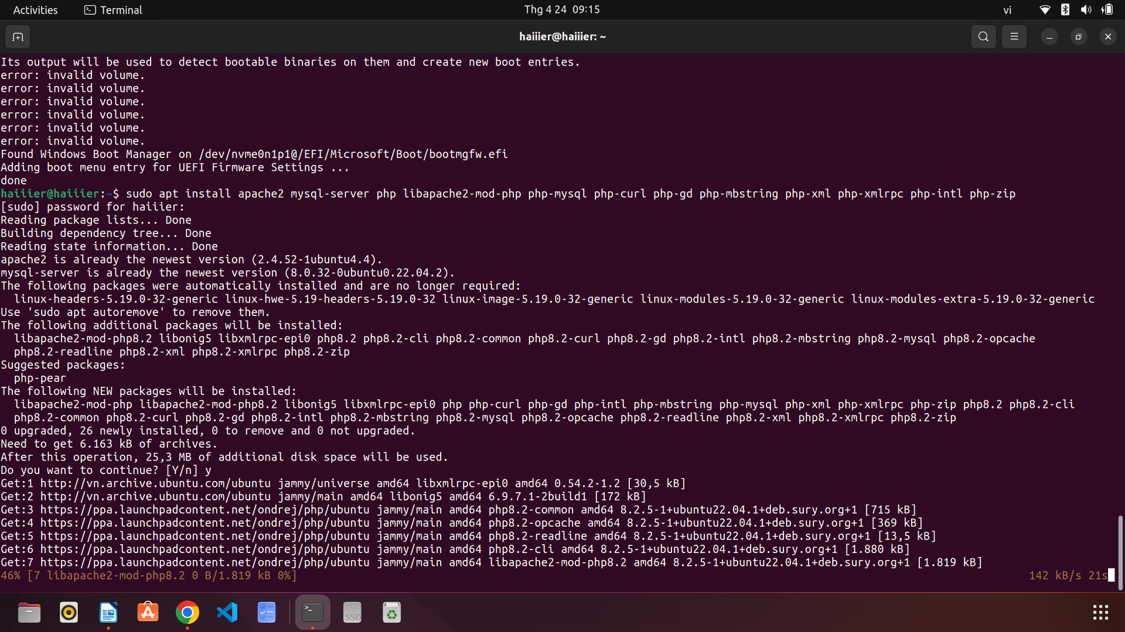

3. Create a new MySQL database for OpenCart:

sudo mysql -u root -p

```

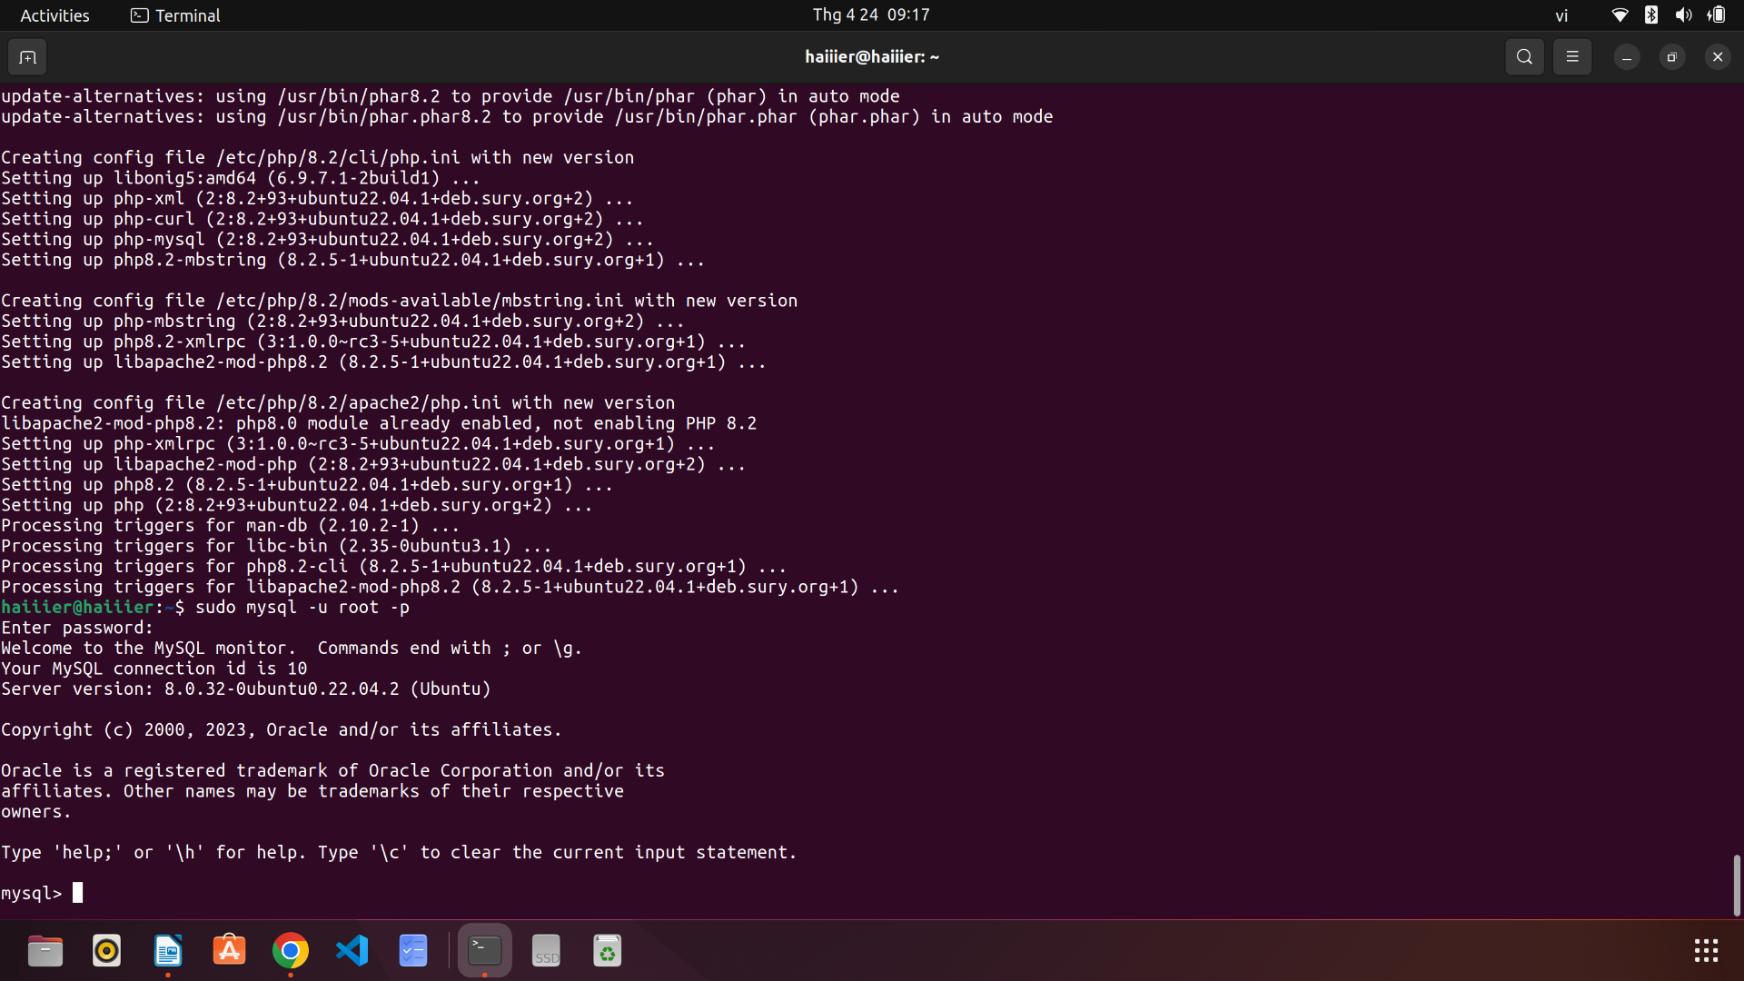

```

CREATE DATABASE opencart;

GRANT ALL PRIVILEGES ON opencart.* TO 'opencartuser'@'localhost' IDENTIFIED BY 'your_password';

FLUSH PRIVILEGES;

EXIT;

```

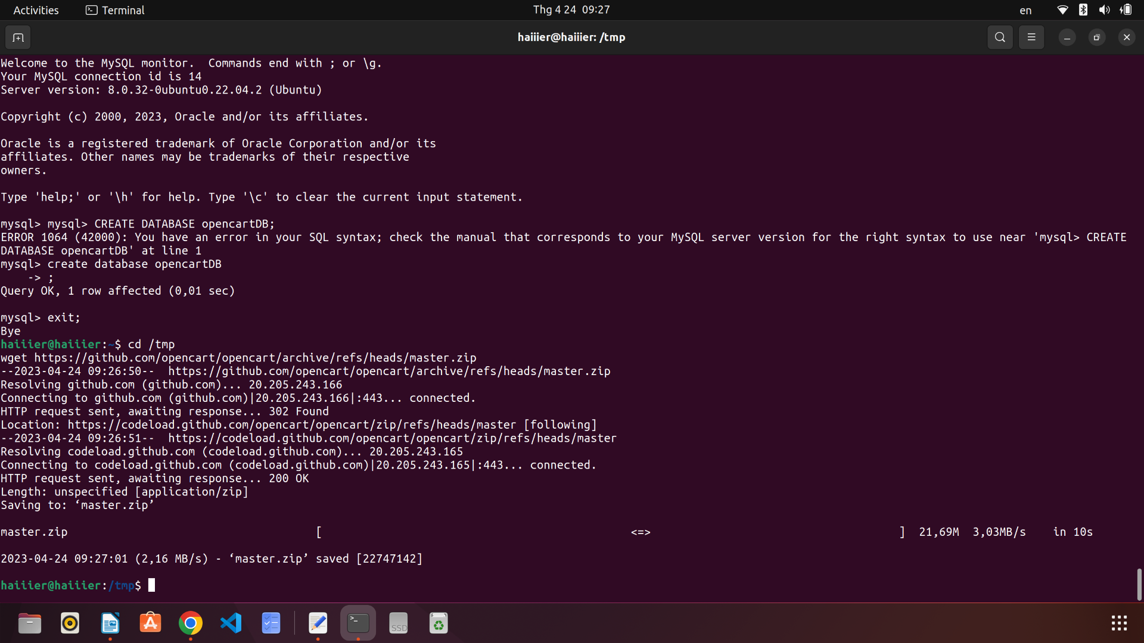

4. Download the latest version of OpenCart from the official website:

wget https://github.com/opencart/opencart/releases/download/3.0.3.7/opencart-3.0.3.7.zip

```

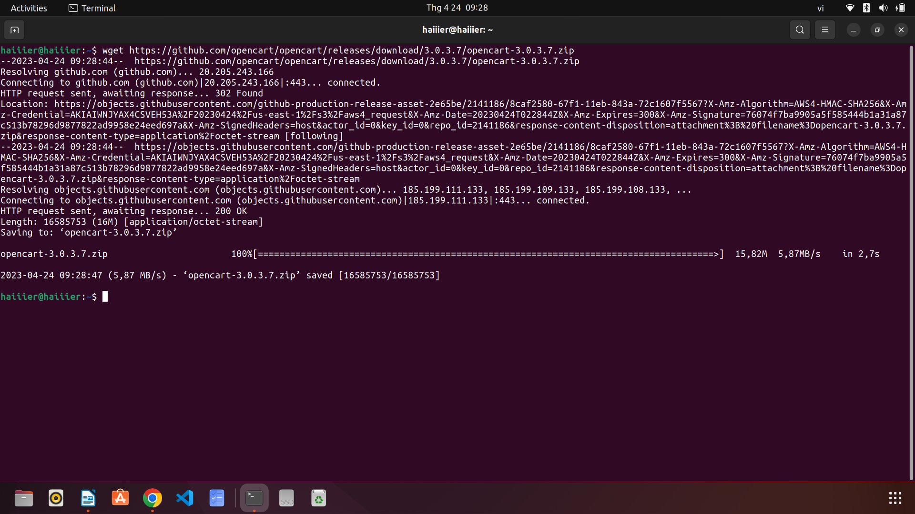

5. Extract the downloaded zip file:

unzip opencart-3.0.3.7.zip

```

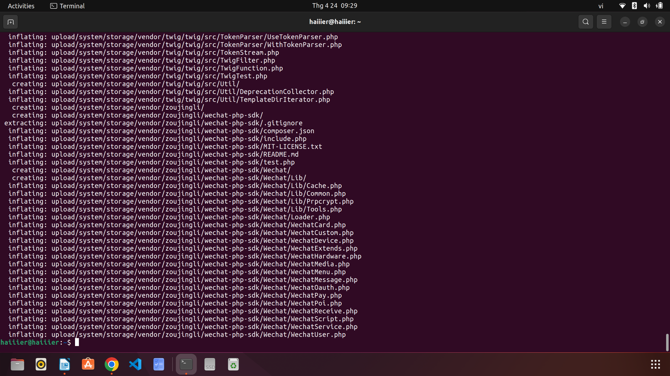

6. Move the extracted files to the Apache webroot directory:

sudo mv upload/ /var/www/html/opencart/

```

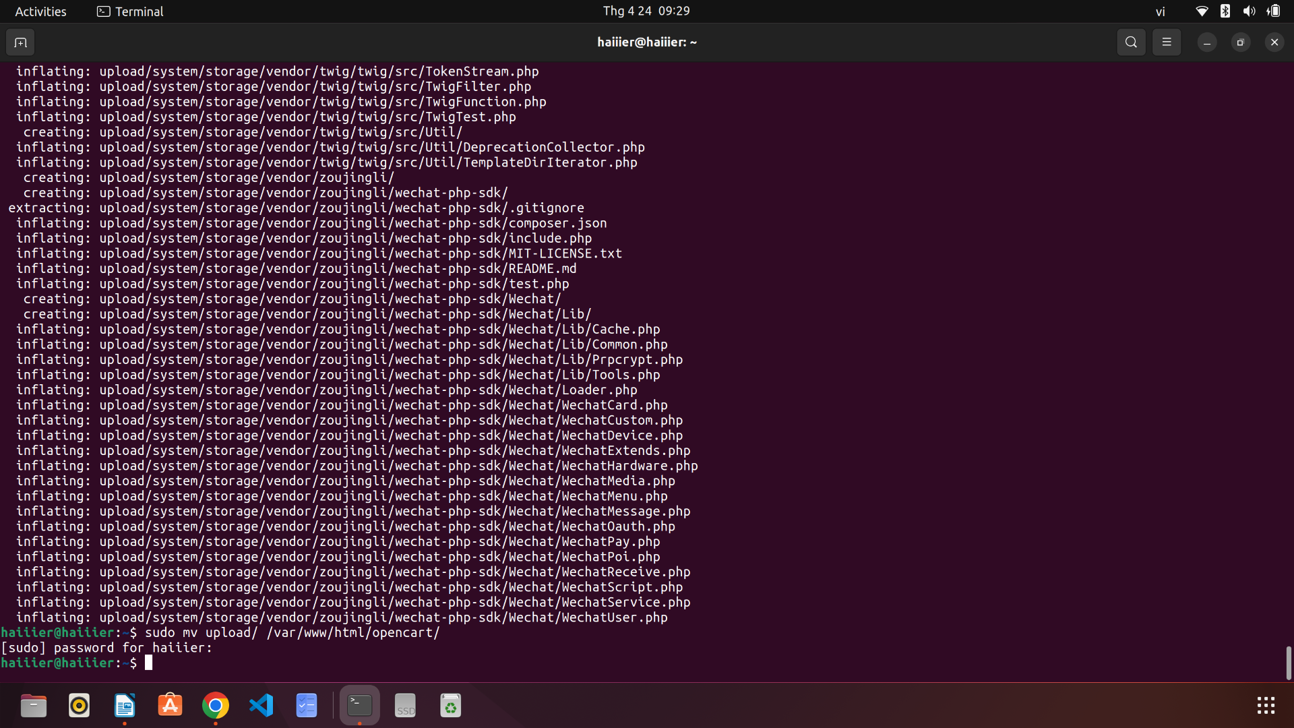

7. Set the correct permissions:

sudo chown -R www-data:www-data /var/www/html/opencart/

sudo chmod -R 755 /var/www/html/opencart/

```

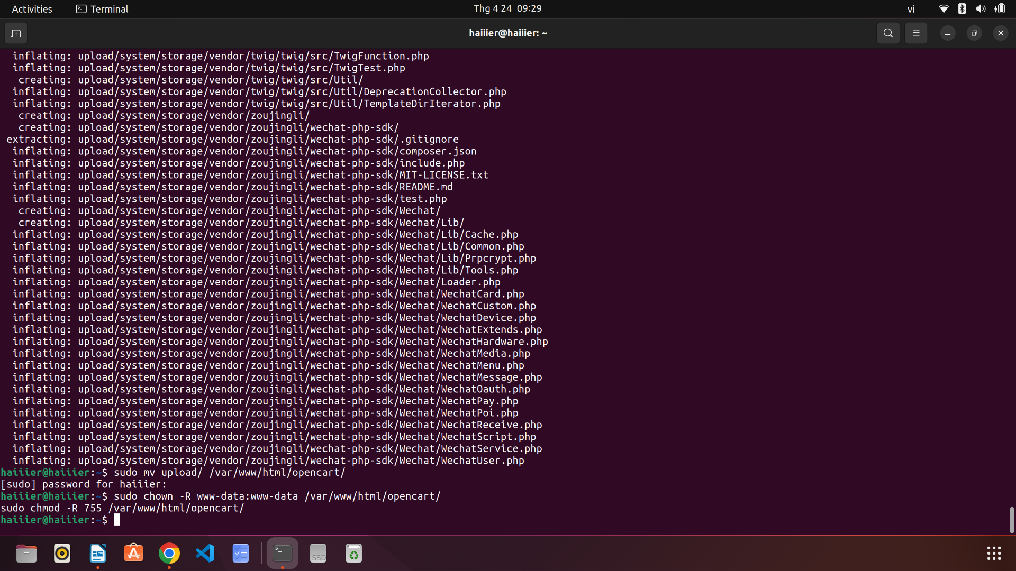

8. Rename the `config-dist.php` file to `config.php` and `admin/config-dist.php` to `admin/config.php`:

sudo mv /var/www/html/opencart/config-dist.php /var/www/html/opencart/config.php

sudo mv /var/www/html/opencart/admin/config-dist.php /var/www/html/opencart/admin/config.php

```

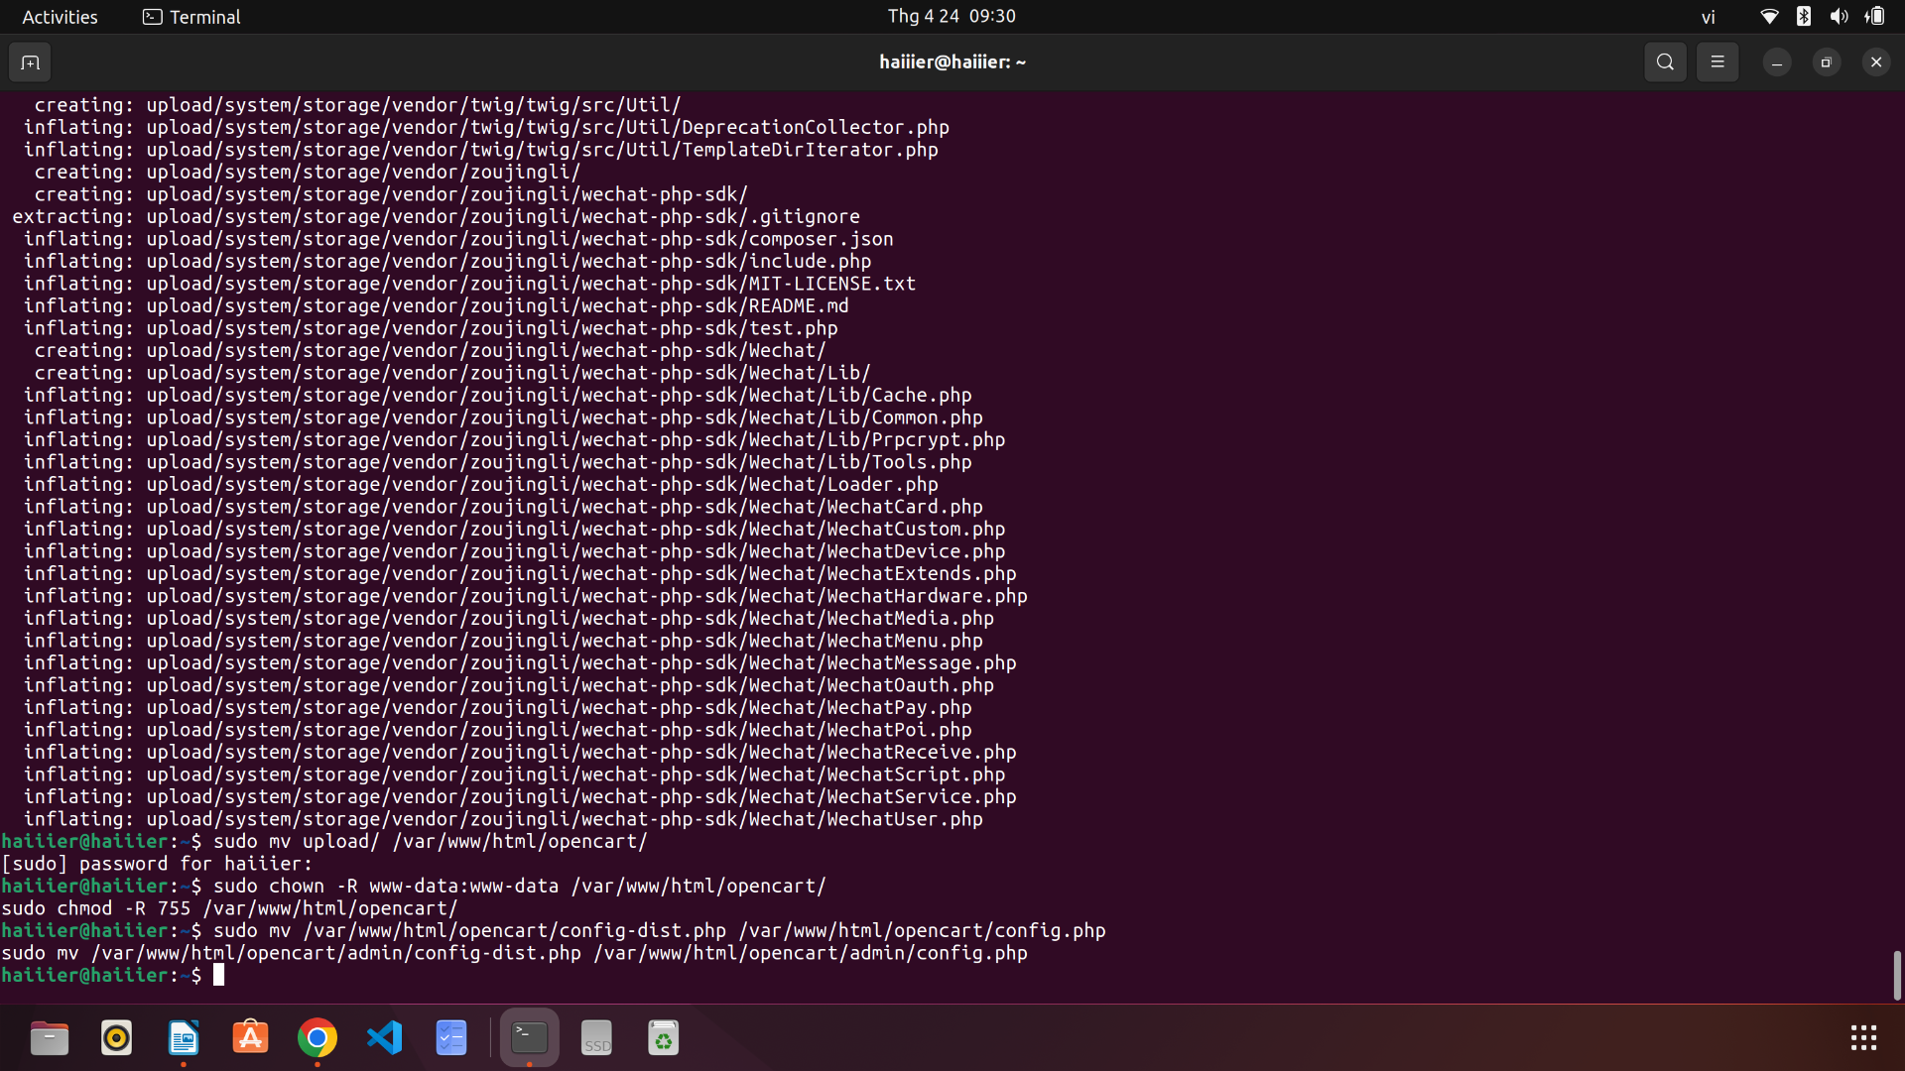

9. Edit the `config.php` file:

sudo nano /var/www/html/opencart/config.php

```

Change the following lines:

define('DB_USERNAME', 'opencartuser');

define('DB_PASSWORD', '1234');

define('DB_DATABASE', 'opencart');

define('DB_PORT', '3306');

define('DB_PREFIX', 'oc_');

```

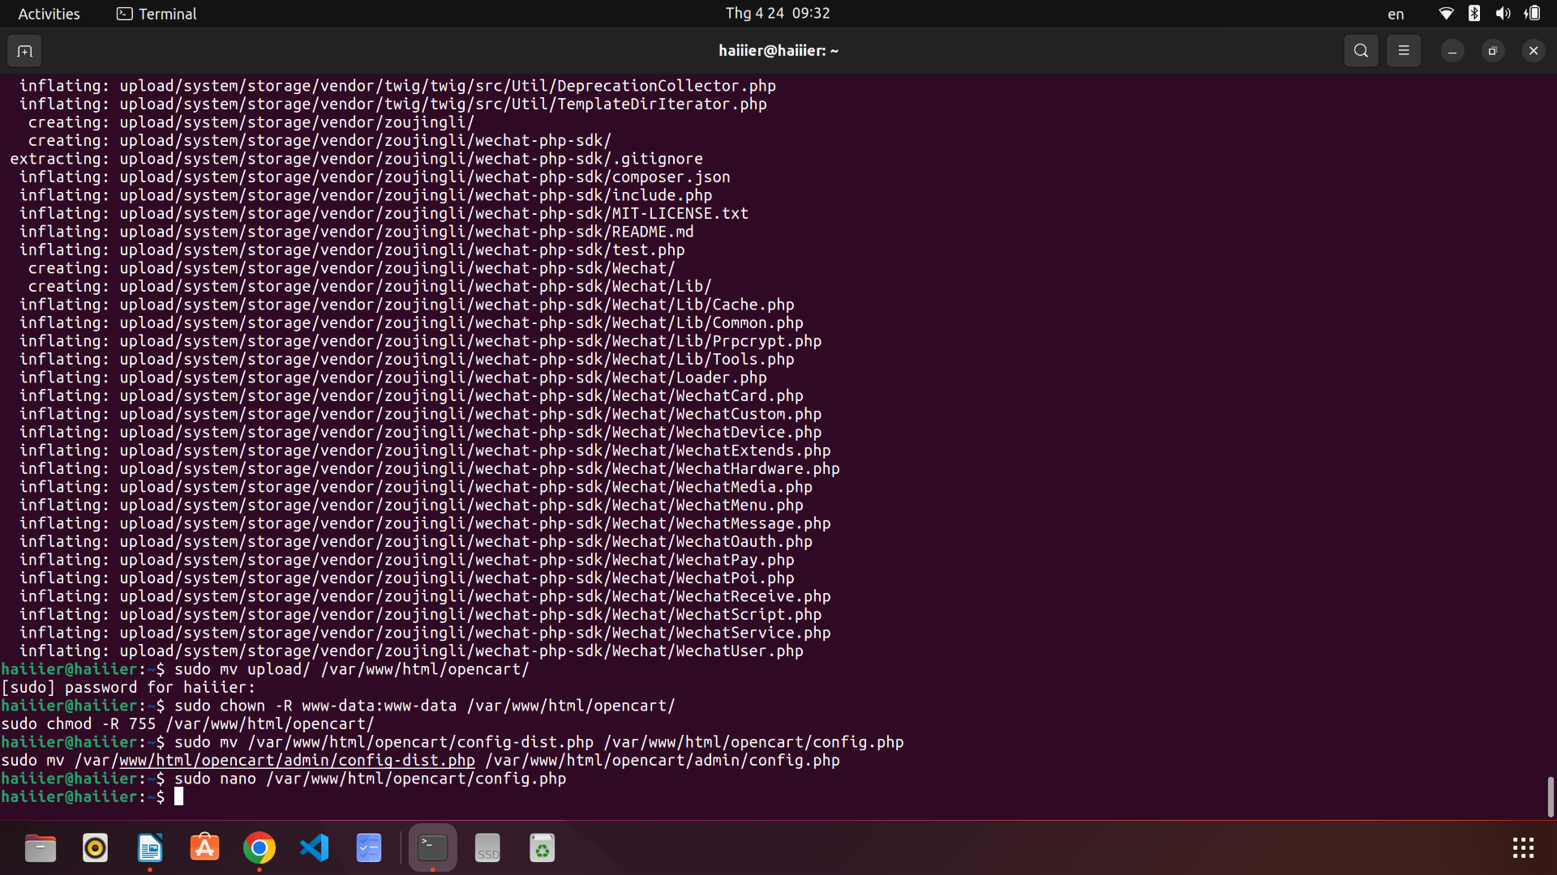

10. Edit the `admin/config.php` file:

sudo nano /var/www/html/opencart/admin/config.php

```

Change the following lines:

```php

define('DB_USERNAME', 'opencartuser');

define('DB_PASSWORD', '1234');

define('DB_DATABASE', 'opencart');

define('DB_PORT', '3306');

define('DB_PREFIX', 'oc_');

```

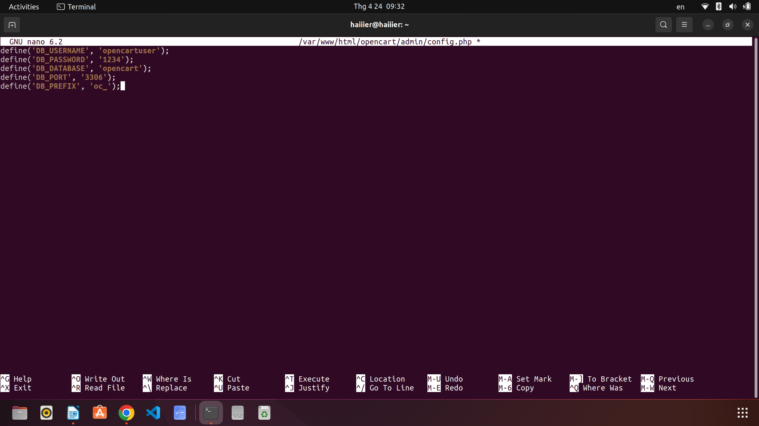

11. Restart Apache:

sudo service apache2 restart

```

12. Open a web browser and navigate to `http://your_server_ip/opencart/` to access the OpenCart installation wizard.

That's it! You have successfully installed OpenCart on Ubuntu 22.04.